Vilvesh Srinivasan

COSC 2436

6/19/2017

Elements vs Execution Time for Heap Sort and Bubble Sort Algorithm

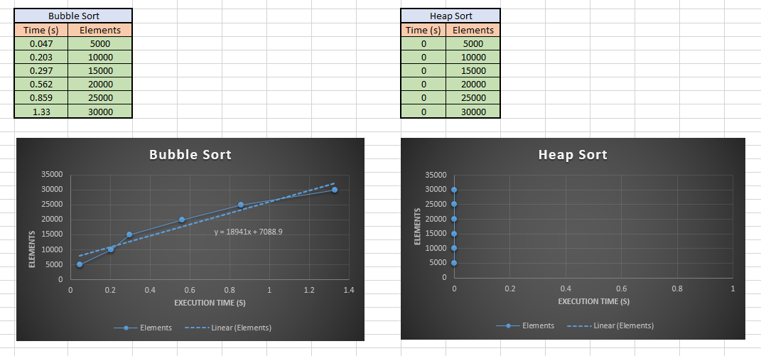

x = 0

**Conclusion:**

Heap Sort is a lot faster than Bubble Sort!